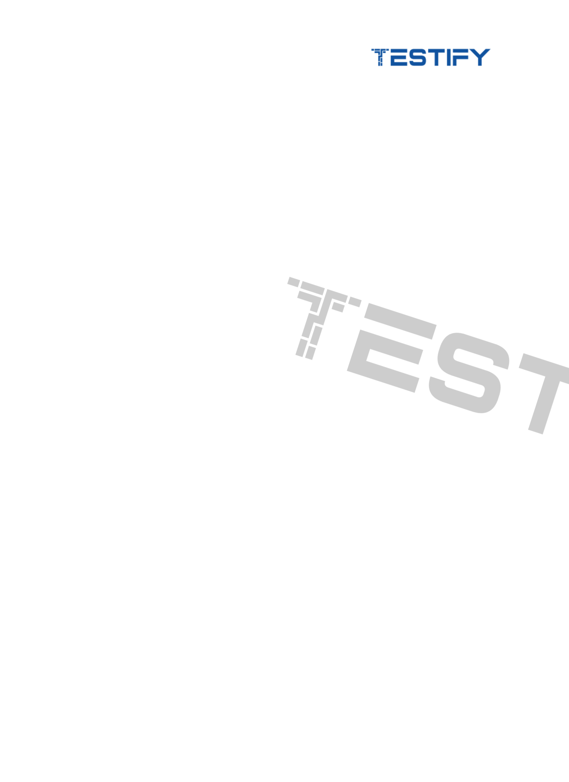
Test Summary Report

Project Name: [Insert Project Name]

Version/Release: [Insert Version/Release Number]

Report Date: [Insert Date]

Prepared By: [Insert Name/Role]

Reviewed By: [Insert Name/Role]

Test Cycle: [Insert Test Cycle Duration]

Test Environment: [Development/QA/Staging/Production]

1. Objective

The objective of this test cycle is to validate the functionality and performance of the new features introduced in version 2.0 of the [project/product].

2. Test Scope

Describe what was covered in the testing cycle, including:

- Features/modules tested.

- Types of testing (Functional, Regression, Integration, etc.).

- Platforms or environments tested (web, mobile, API, etc.).

3. Test Metrics Overview

Provide a summary of key metrics for test, and defect:

Test Metrics

Module/ | Count | Passed Test | Failed Test | Not
Feature |  | Cases | Cases | Executed
 |  |  |  | Test Cases
Feature 1 | X | X | X | X
Module 1 | X | X | X | X

Bug Merics

Module/ | Defects | Defects | Defects | Next Sprint
Feature | Logged | Closed | Open | Feature
Feature 1 | X | X | X | X
Feature 2 | X | X | X | X

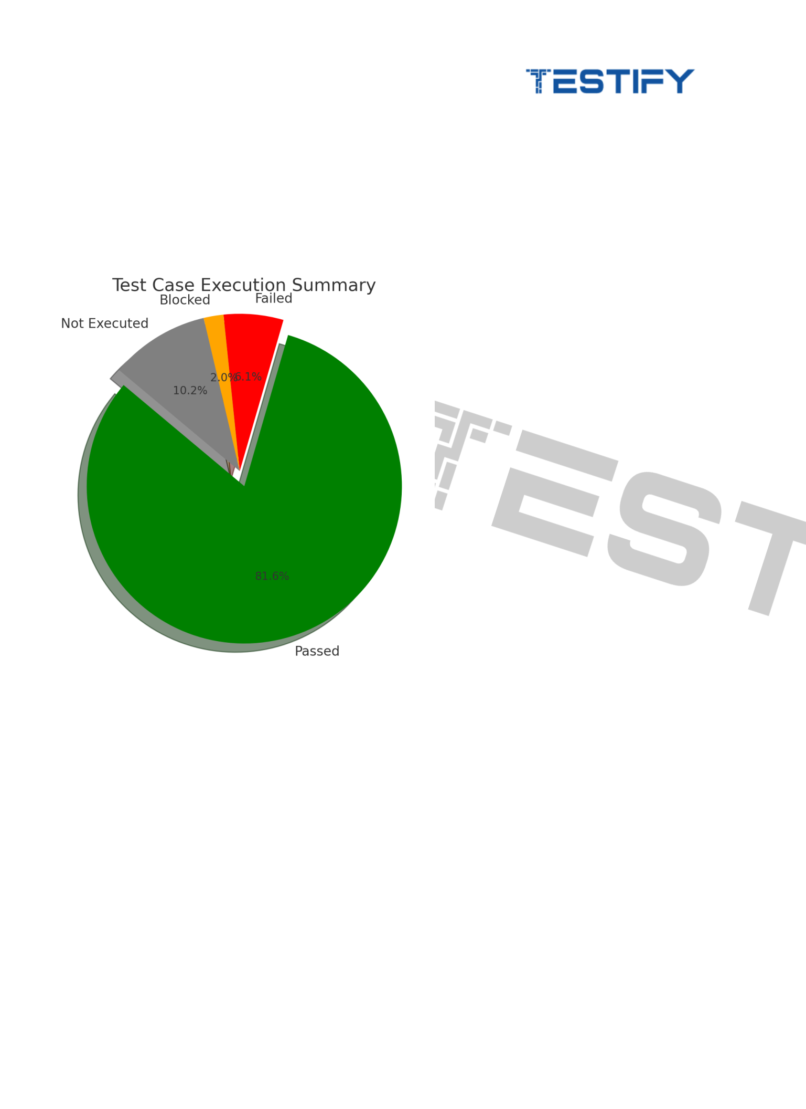

4. Test Case Execution Status

The following pie chart visualizes the execution summary, showing the percentage distribution of Passed, Failed, Blocked, and Not Executed test cases.

- Green for Passed

- Red for Failed

- Orange for Blocked

- Grey for Not Executed
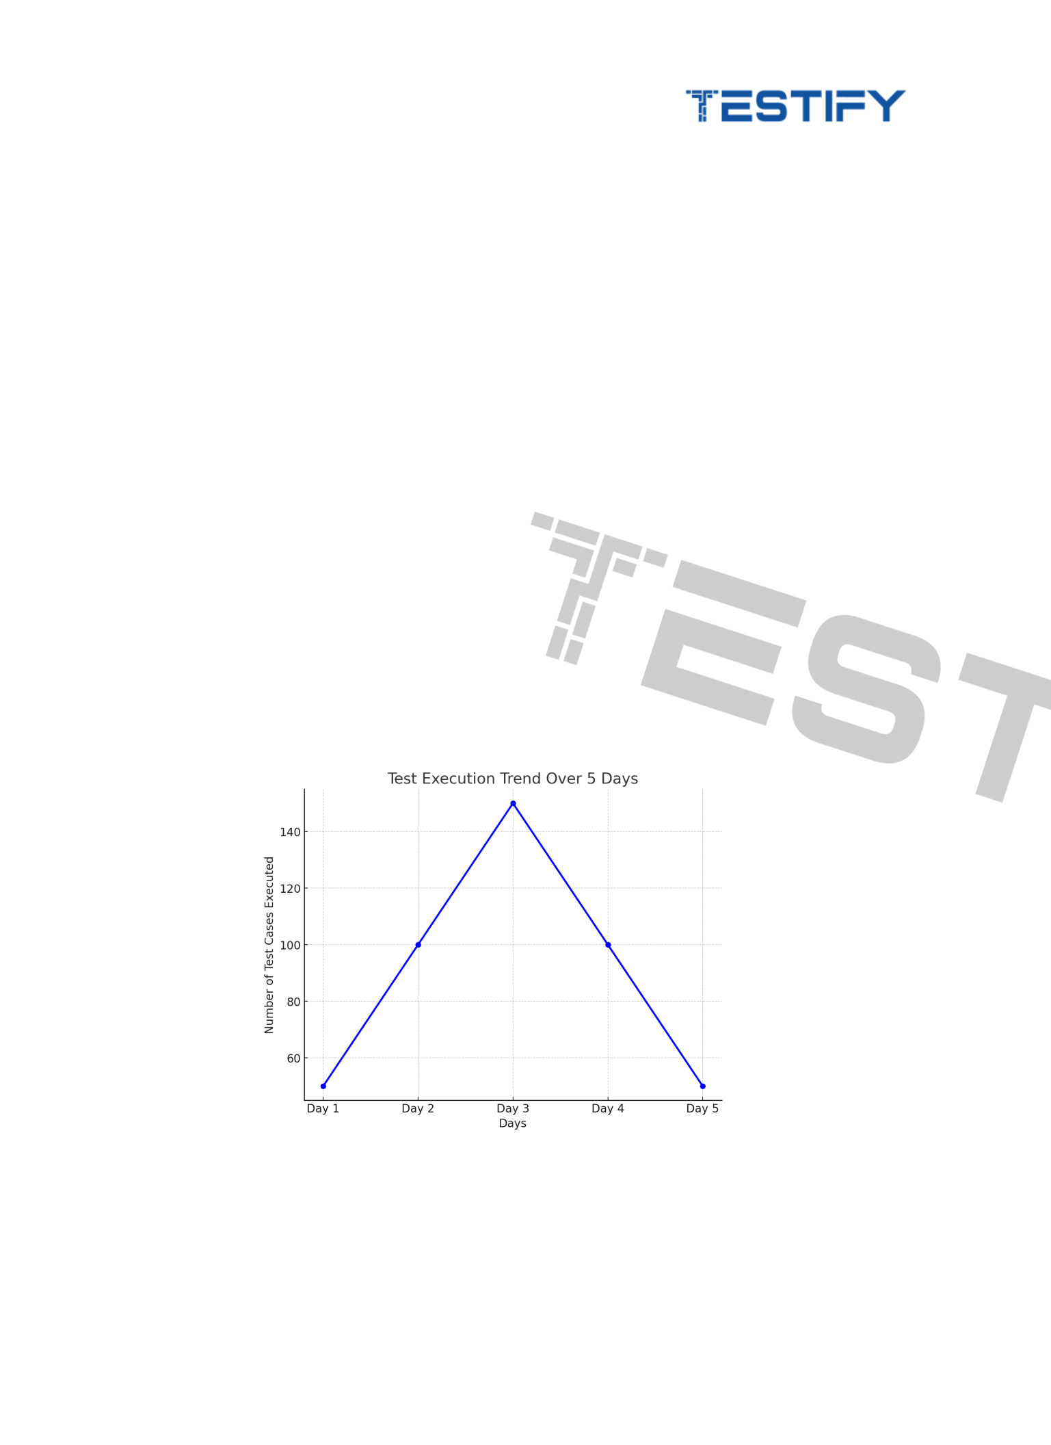

5. Defect Summary

Provide a summary of the defects logged, categorized by severity or priority:

Defect | Critical | High | Medium | Low | Count
Severity
Module 1 | 5 | 10 | 15 | 10 | 40
Featuree 1 | 10

6. Test Execution Trend

The following line chart illustrates the number of test cases executed over a 5-day period, providing insights into the testing progress and any delays or inconsistencies in execution.

7. Defect Aging

This section helps stakeholders understand how long defects have been open and whether there are any bottlenecks in resolving issues.
Defect Logs

Defect ID | Defect Description
DEF-001 | Decribe the defects here
DEF-002 | Decribe the defects here
DEF-003 | Decribe the defects here
Defect Age
Defect ID |  | Severity | Status | Date Logged | Days Open
DEF-001 |  | Critical | Open | 2024-10-25 | 2
DEF-002 |  | High | Closed | 2024-10-23 | 0
DEF-003 |  | Medium | In Progress | 2024-10-24 | 1

8. Test Coverage

Illustrate the overall test coverage using the following key areas:

- Requirements Coverage: The percentage of requirements covered by tests.

- Code Coverage (if applicable): The percentage of code that has been executed during testing.

Use a bar chart to visualize requirements versus covered requirements, helping stakeholders assess how thoroughly the testing addressed product risks.

9. Risks and Issues

Highlight any risks or blockers encountered during the testing cycle that may affect the release timeline or product quality.

10. Detailed Summary

Explain how testing the application was and activities that might have infuenced this result

11. Recommendations

Provide actionable recommendations based on test results.

12. Conclusion

Summarize the overall quality of the product based on test execution and defect status, and provide a recommendation on whether the product is ready for release.

Example:

- Based on the current test results, the product is in good condition with minimal critical defects. However, further testing is recommended on the checkout module before production release.

